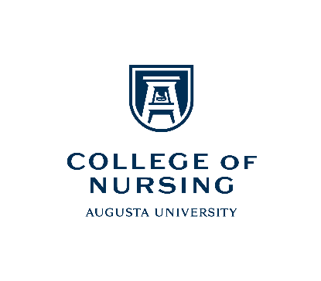

Nursing Scholars Program
Purpose
The Nursing Scholars Program aims to enhance the undergraduate education of Augusta University’s academically talented freshmen and sophomores with proven dedication to academic excellence and scholarship who are interested in pursuing careers as professional registered nurses. The program aims to support academic excellence and foster a culture of research and scholarship among select pre-nursing students who will matriculate into the BSN Program. The program will broaden the scope of enrichment opportunities that strengthen students individually while developing collegial leadership skills to serve in an interdisciplinary and multicultural environment.
Eligibility Criteria
- Apply for undergraduate admission to Augusta University by the Early Action deadline of October 31st (applications become available in August of your senior year in high school)
- Submit a Nursing Scholars Program Supplemental application by the December 31st due date (qualifying applicants will be contacted and offered a secondary application)
- Submit two supportive references who are not relatives, from a science instructor/assistant, coach, or employer (at least one MUST be from a science instructor or their assistant)
Ongoing Requirements
- Consent and adhere to the Nursing Scholars Course Progression Agreement
- Maintain an overall GPA of 3.5 or better.
- Achieve a Math/Science GPA of 3.0 or better in pre-nursing courses.
- Actively participate in the Pre-Nursing Society (may include learning environment tours or shadowing opportunities); participates in at least two events per semester during the academic year.
- Work towards the Certificate Leadership program at Augusta University.
- Continue scheduled advisement sessions with a designated advisor in the Academic Advisement Center on the Summerville campus.
- Meet bi-annually with the College of Nursing designated faculty advisor.
- Meet and maintain the College of Nursing Academic Conduct, Professional Behaviors and Values, and Social Media policies.
- Periodically participate in at least two open College of Nursing events annually (e.g., Education Information Sessions, Costa Layman, Sigma Theta Tau Evidence-Based Practice event, alumni weekend distinguished guest lecture presentations, etc.); submit proof of attendance.
Application Process
- Complete a Nursing Scholars Program supplemental application.
- Submit a 500-word essay/personal statement detailing your interest in pursuing a professional nursing career.
- Upon acceptance as a nursing scholar, participants will be required to sign a Nursing Scholars Course Progression Agreement.
- Upon acceptance as a nursing scholar, participants will be required to obtain a TEAS exam score of 75 or better by the end of December during their sophomore year (as is required of all other BSN program applicants)
- Competitive students will be selected and notified by the Office of Undergraduate Admissions via email by March 1.
Description and Guidelines

TP TPB; 092823

