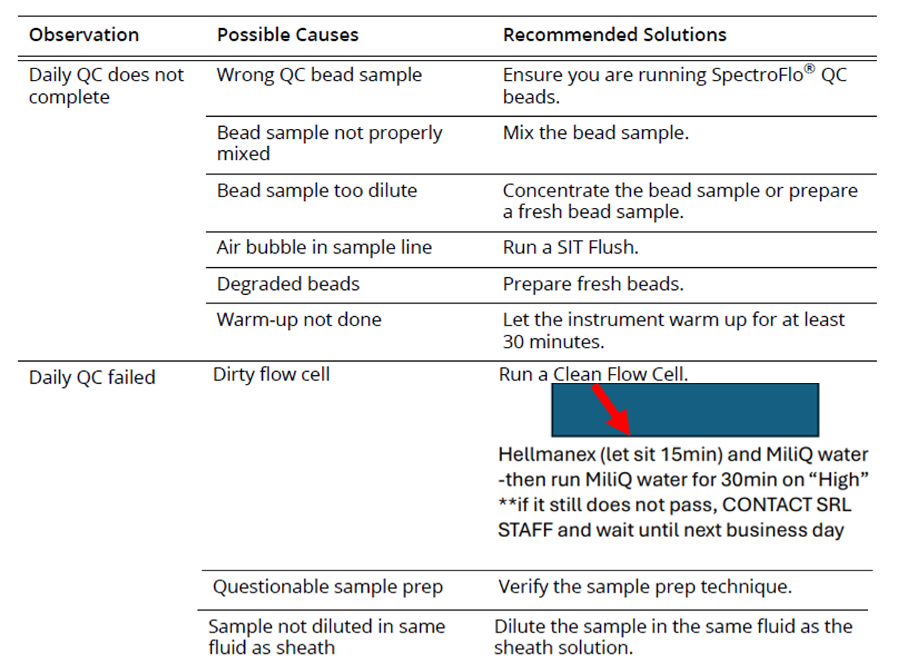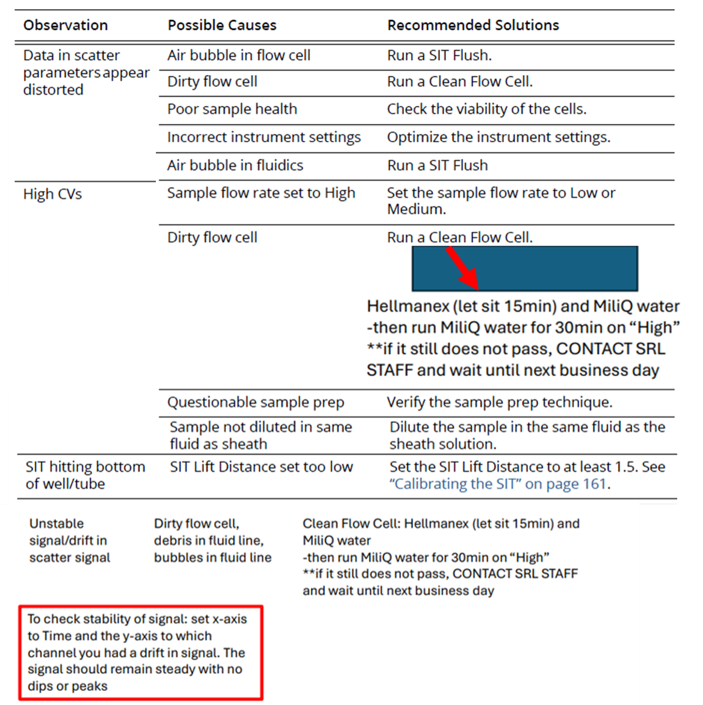
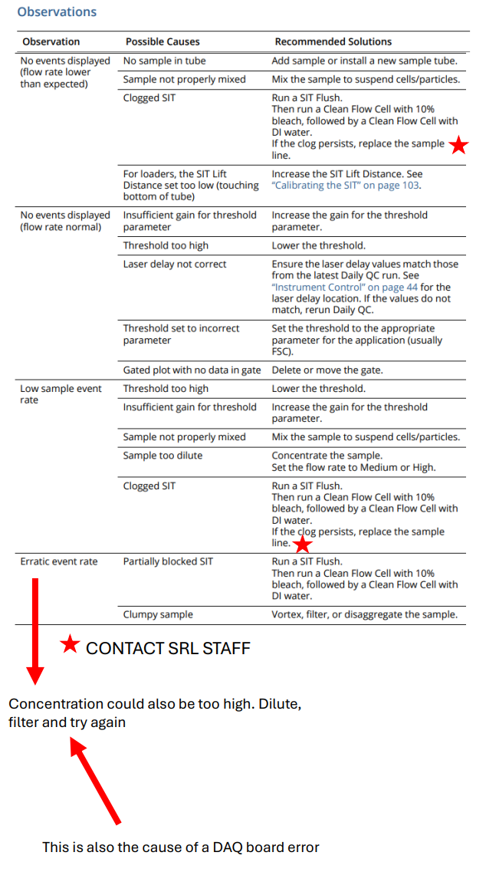
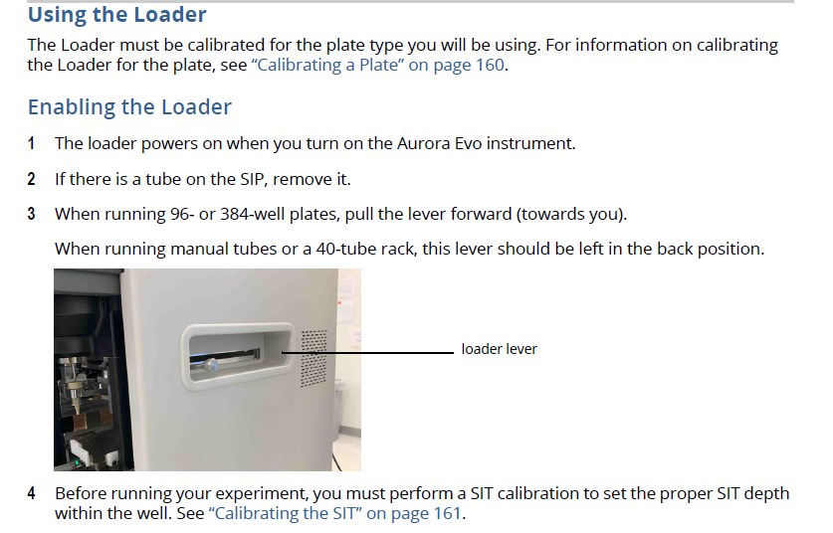
For information on setting up an experiment using the plate loader, See pg 152 in the EVO user manual. The user manual can be found under the “Help” tab in the SpectroFlo software.

