GCC Flow and Mass Cytometry Shared Resource: Facility Contact Details
Analyzer Room: CN 4158C 1-5468
Data Analysis Room: CN 4158D
Sort Room: CN 4146C 1-8473
Rebekah Tritz (Research Manager): CN 4158E 1-5468
David Hansen (Senior Research Assoc.): CN 4121A 1-8880
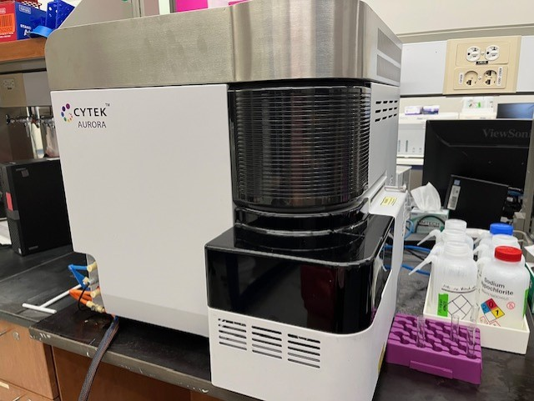

Contents
Facility Contact Details ……………………………………………………………………………………………………………………………1
Important Points …………………………………………………………………………………………………………………………………….2
Sample Preparation ………………………………………………………………………………………………………………………………..3
Instrument Start-up ……………………………………………………………………………………………………………………………….3
Fluidics ……………………………………………………………………………………………………………………………………………………3
Sheath
Waste
SpectroFlo: sample set-up and acquisition in a new experiment …………………………………………………………….3
Instrument Cleaning and Shutdown ………………………………………………………………………………………………………5
Exporting Data ………………………………………………………………………………………………………………………………………..5
Data Analysis ………………………………………………………………………………………………………………………………………….5
Additional Cleaning/ Setting options ………………………………………………………………………………………………………5

Important Points:
- If an issue arises which you are unsure how to resolve, please do NOT try and fix it yourself – Please contact a GCC Flow and Mass Cytometry SRL staff member (leave a note and send an email if the problem arises outside of business hours)
- All users MUST be trained by the GCC Flow and Mass Cytometry SRL staff to use the instrument and be familiar with the SRL policies. Disregarding SOPs or abuse of the machines will result in suspension of SRL access. For training, please contact the GCC Flow Cytometry SRL staff.
- Correct shutdown and cleaning procedures MUST be adhered followed. Failure to do so can result in instrument malfunction and affect data quality of the next user.
- SpectroFlo software can be accessed on a PC in 4158C. Please contact SRL staff to setup your lab’s account in the software. If you need any assistance, please contact SRL staff.

Sample Preparation:
- Instruments –
  - Aurora: equipped with 355, 405nm, 488nm, 561nm and 640nm lasers, allowing detection of signals in 64 fluorescent channels.
- Instrument specifications are available at https://www.augusta.edu/cancer/research/shared-resources/flow/equipment.php.
- The SRL facility recommends using FluoroFinder (https://fluorofinder.com/) or Cytek Cloud (https://cloud.cytekbio.com/login) for custom panel design specific to GCC Flow Cytometry SRL machines. If you require assistance developing a panel or navigating panel building sites please contact SRL staff.
- ALL samples that are not from whole blood MUST be filtered through a (minimum) 70uM mesh filter before acquisition – NO EXCEPTIONS. Specimens must be inactivated of all pathogens before they are brought into the facility. Commonly, 1-2% paraformaldehyde is used.
- All samples must be resuspended at an appropriate concentration to not block the SIP (sample injection probe). Users who continue to block the SIP through neglectful sample preparation may have their usage revoked.
- Samples may be brought in 12x75mm tubes or standard sized 96 wells plate.

Instrument Start-up:
- The power button is on the left-side of the Aurora. However, the SRL staff request that the Aurora remain turned on. This keeps the fan on and allows for better temperature maintenance.
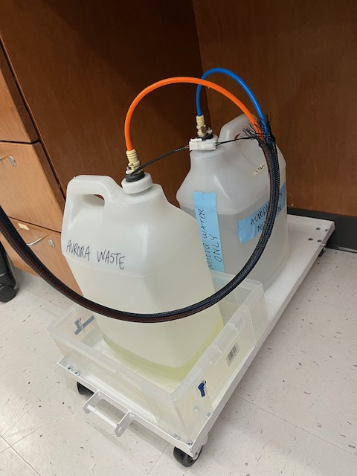
  - Sheath:
    - Use Mili-Q water ONLY
    - When the sheath needs to be refilled the status light (lower right) in the software will turn yellow or red.
    - When the sheath needs to be added, disconnect the blue line to the cap and fill with Mili-Q water from the dispenser next to the sink. Make sure the line is completely clicked in when reconnecting.
  - Waste:
    - When the waste is too full the status light will change on the software (same location as “sheath”) in similar fashion to the sheath. Remove the cap and empty the waste container in the sink and add 300mL undiluted bleach and reconnect the waste cap.
SpectroFlo Software Navigation (sample set-up, acquisition in a new experiment)
- Log in to PC using the core credentials – username: Cytek password: Welcome#1
and begin your session in iLab (Kiosk)
- BEFORE logging into SpectroFlo software, make sure there is a tube of water on the SIP
- If you are performing your experiment during normal SRL operation hours (M-F, 9a-5p) the Aurora software will already have been opened and the warm-up and QC performed. If this is true, skip to #5. If you are running an experiment outside of normal SRL hours you will need to start at #4.
- First user of the day:
  - After logging into SpectroFlo software go to “Acquisition” module
  - Open “Default” experiment
  - Run FACs clean (10% bleach) for 10 minutes
  - Run water for 20 minutes
  - Prepare SpectroFlo QC beads – 1 drop of beads in 150uL MiliQ water
  - Open “QC & Setup” tab
  - Ensure correct/current bead lot # is selected
  - Load SpectroFlo beads, click “Start” and run
  - Status of QC run will appear after done and will allow you to view the report
  - PERFORM DAILY CLEAN – software wizard will provide steps
- Check the “Library” before you create your experiment to see if all your fluorophores are listed, if not, add them
- Click “Data Acquisition” tab to create new experiment, open default experiment or template and import/duplicate an experiment
“New Experiment”
- If using a 96-well plate:
  - After daily set-up, turn on loader power
  - REMOVE 12x75 tube from SIP, then manually move the “Loader Mixer” forward
- Select all the fluorescent tags in your sample. Check the “Library”
- Groups:
  - Carrier Type – select tubes or the appropriate 96-well plate (see above for getting the machine into the correct position)
  - Reference group – make sure to select the appropriate controls for the reference samples (beads vs cells). Consult core staff for help with assigning additional negatives.
  - Sample groups – organize groups and samples to best fit the organization of the experiment
- Markers: at this point markers can be entered for the different fluorescent tags. This is optional and not necessary for proper machine set-up.
- Keywords: optional
- Acquisition: select parameters at which point the sample stops running (events, volume, or time)
- At this point everything can be saved as a template or saved and opened as a new experiment
- Running samples:
  - Acquisition control –
    - Flow rate: low, medium, high
    - Start vs record
    - Live feed on sample running: event rate, time elapsed, abort rate etc
  - Instrument control –
    - FSC, SSC and SSC-B: adjust voltage in order get cell populations within range
    - Other fluorescent channels: do not adjust voltages of these channels. If there is a fluorophore that reads off scale, then titration is needed.

- Unmixing:
  - Select controls:
    - Dictate the control to be used for the reference controls (library vs experiment)
    - Decide whether the reference samples to be used will be generic or from the library.
    - “Autofluorescence as a fluorescent tag” – can use autofluorescence of sample as an additional parameter.
  - Identify Positive/ Negative populations: go through each reference sample and make sure the appropriate positive and negative gate is set.
  - If properly unmixed, the software will produce simplified spectral signatures for each sample and a similarity matrix for all selected fluorophores.
  - “Live Unmix” vs “Create New Unmixed Experiment” – for immediate application of unmixing to the experiment select “Live Unmix”
Instrument Cleaning and Shutdown:
- Clean flow cell:
  - Tube #1 – Hellmanex
  - Tube #2 – MiliQ Water
- Daily Clean: must be done at the end of every appointment.
  - Software wizard will provide steps.
Exporting Data: After experiment is complete, close the experiment tab. Do NOT save the current experiment raw worksheet settings as the new default. To export your experiment, select “My Experiments”. This will list all saved experiments in your login profile. Selecting an experiment and “Export” will put both Raw and Unmixed data into individual folders. These files must be transferred off the computer using Box or Google drive.
Data Analysis: Data can be analyzed either on the Aurora or the offline computer with the SpectroFlo software. The exported FCS files can be analyzed with FlowJo or FCS-Express. If concentrated help is needed on analysis, please contact SRL staff.
Additional cleaning/ setting options: each can be walked through by following the software wizard
  - SIT Flush
  - Calibrate SIT
  - Clean Flow Cell
  - Calibrate Plate
  - Statistics and Spillover changes

