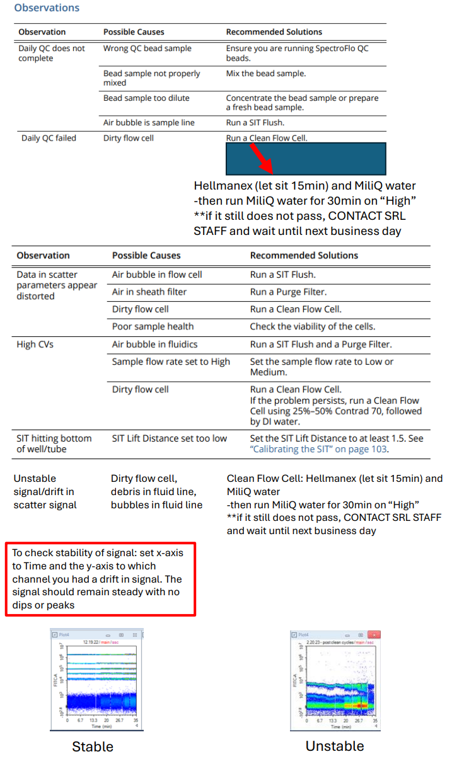
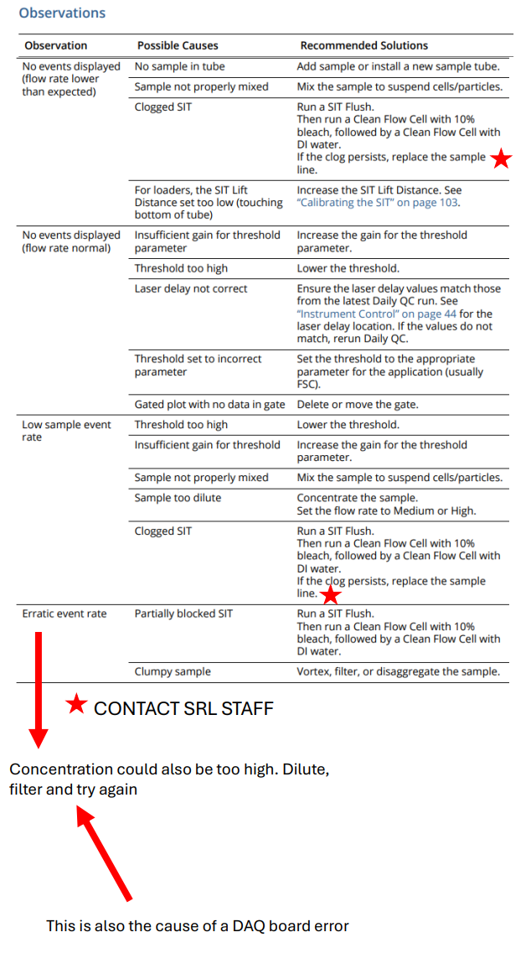
If automatic SIT flush does not happen, it could be because the sensor tab did not fall when the tube was removed. Open the curved portion of the Aurora. Next to the sample line you will see a small metal tab poking up in between a black U-shaped piece (see picture below). Take a pipette tip and gently click the metal tab down. Note: THIS IS ONLY DONE WHEN THE CYTOMETER DOES NOT RECOGNIZE A TUBE HAS BEEN REMOVED.
